**Smart Switch (Home Automation)**

Components Required to construct:

1. Arduino UNO R3 with connecting cable.
2. 2 or 4 Channel 5V Relay module (Optocoupler).
3. Jumper Wires (Male to Male & Male to Female).
4. Breadboard (Small).
5. Ultrasonic Sensor (HC SR04).
6. AC LED Bulb.
7. DC Fan.
8. Connecting Wires.

**Project Code:**

#define relay1 4

#define relay2 5

Const int trigPin=9;

Const int echoPin=10;

long duration;

int distance;

void setup()

{

pinMode(trigPin, OUTPUT);

pinMode(echoPin, INPUT);

pinMode(relay1, OUTPUT);

pinMode(relay2, OUTPUT);

Serial.begin(9600);

}

Void loop()

{

digitalWrite(trigPin, LOW);

delayMicroseconds(2);

digitalWrite(trigPin, HIGH);

digitalWrite(trigPin, LOW);

duration=pulseln(echoPin, HIGH);

distance= duration*0.034/2;

Serial.print(“distance”);

Serial.println(diatance);

delay(2000);

if (distance < 15)

{

digitalWrite(relay1, HIGH);

digitalWrite(relay2, LOW);

Serial.print(“relay1, HIGH”);

delay(100);

}

if (distance > 15 && distance < 30)

{

digitalWrite(relay2, HIGH):

digitalWrite(relay1, LOW);

Serial.print(“relay2, HIGH”);

Delay(100);

}

If (distance > 30)

{

digitalWrite(relay1, LOW);

digitalWrite(relay2, LOW);

Serial.print(“relay1, LOW”);

Serial.print(“relay2, LOW”);

}

}

**Components Images:**

1. **Arduino uno r3**

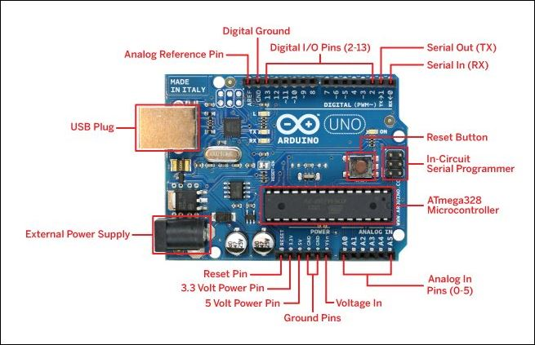

1. **Ultrasonic sensor (HC SR04)**

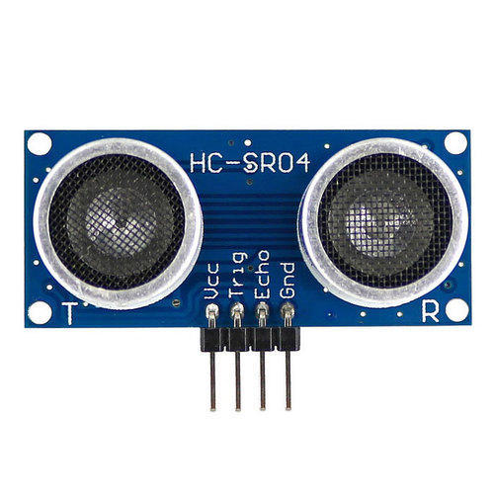

1. **5V Relay Module (Optocoupler)**

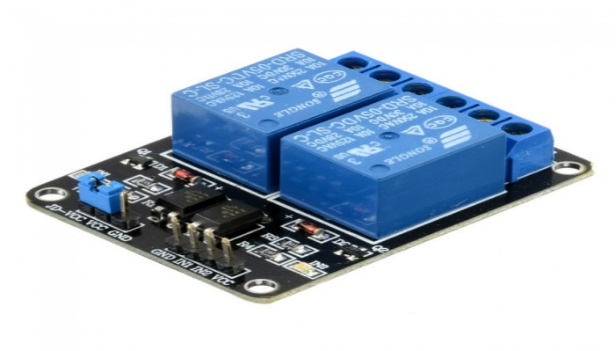

1. **Breadboard**

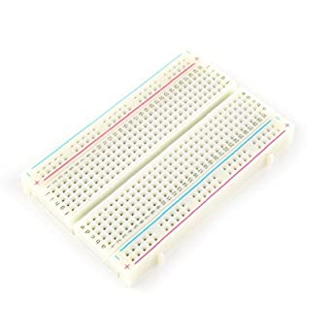

1. **Jumper wires (Male to Male) & (Female to Male)**

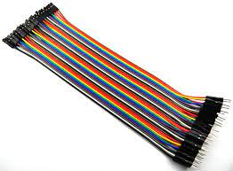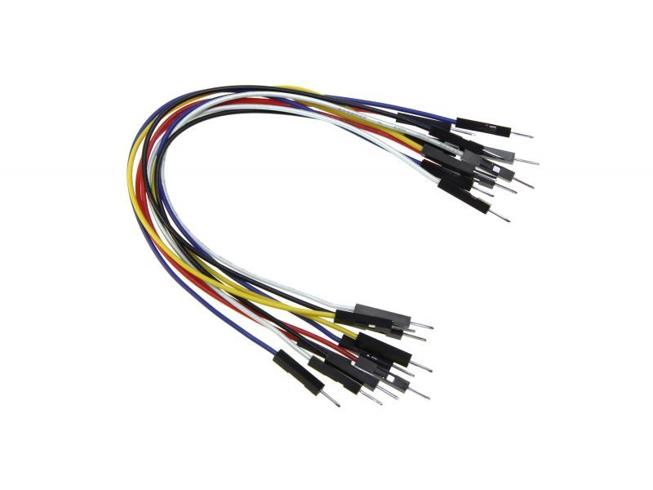

1. **AC Led Bulb**

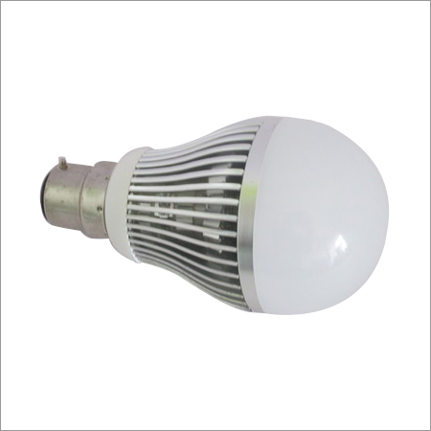

1. **DC Fan 12V**

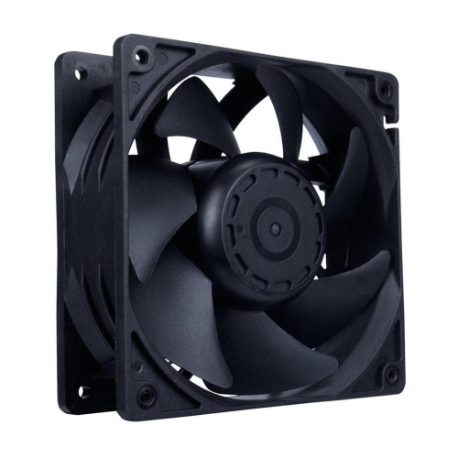

**Connections:**

1. Breadboard and Arduino Uno

* Connect 5V Pin on the left side (Power Pins ) to the Red Rail (+) and Ground Pin to the Blue Rail (-) to the breadboard from Arduino.

1. Connecting HC SR04 to breadboard and to the Arduino uno

* Plug the sensor board horizontal to the breadboard.
* Connect (+) to the Red Rail and (-) to the Blue Rail.
* Connect Trig Pin to the Pin 4 to the Uno.
* Connect Echo Pin to the Pin 5 to the uno.

1. Connecting 5V Relay module to the breadboard and Arduino

* Connect (+) to the Red Rail and (-) to the Blue rail on breadboard from relay module.
* Connect Pin 1 from Relay module to the Pin 9 on Arduino.
* Connect Pin 2 from Relay Module to the Pin 10 on Arduino.

1. Connecting AC Bulb and DC Fan to Relay Module.